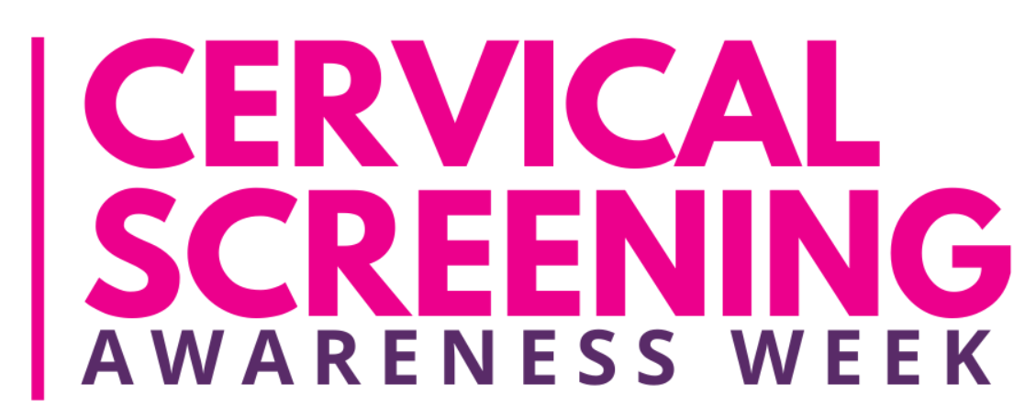

* Cervical screening (a smear test) checks the health of your cervix (the neck of the womb)
* It’s not a test for cancer, it’s to help prevent cancer.
* All women and people with a cervix aged 25 to 64 are eligible and should be invited by letter every three to five years.
* During the screening appointment, a small sample of cells will be taken from your cervix.
* The sample is checked for certain types of human papillomavirus (HPV) that can cause changes to the cells of your cervix. These are called ‘high risk’ types of HPV. If these types of HPV are found, the sample is then checked for any changes in the cells of your cervix. These can then be treated before they get a chance to turn into cervical cancer.
* If you have any questions or concerns about cervical screening at any time, please contact the practice and we will arrange for you to speak to a nurse or a GP to answer your questions.
* If you have any other questions, we are always happy to answer them.